Project to Improve Adherence to International Labor Standards in the Agricultural Sector in Ecuador
FOA-ILAB-23-28
Partners of the Americas
Budget Narrative

- INTRODUCTION

Partners of the Americas (POA) is pleased to present the U.S. Department of Labor funded Project to Improve Adherence to International Labor Standards in the Agricultural Sector in Ecuador with a total cost of $4,740,000 over a 48-month period.

POA will target populations in the regions of El Oro and Cotopaxi with the aim to improve Ecuador’s adherence to international labor standards, specifically related to child labor, forced labor, and the promotion of labor rights, within the banana and cut flower value chains.

Budget Structure
The budget herein presents realistic, reasonable, and justifiable costs of goods and services required for the efficient operation and management of the proposed project. The budget categories conform to the United States Department of Labor (USDOL) budgeting structures and are explained in further detail in ensuing sections. All costs are based on a combination of POA´s experience with similar programs, and historical costs.

POA provides a detailed explanation of the budget line items and the methods used to determine costs associated with implementing the proposed project strategy. POA has established sound financial management and internal control systems ensuring expenditures are reasonable, allowable, and classified in accordance with generally accepted accounting principles (GAAP). POA uses cloud-based accounting software and is subject to an annual A-133 audit. The Finance and Administration (F&A) department is staffed with a talented group of professionals with over 40 years of combined experience in the fields of finance and accounting, auditing and, managing the financial reporting for federal grants, contracts, and overseeing cooperative agreements with USDOL. The finance department is comprised of a Director of Grants and Contract Compliance, a Budget Analyst, an Account Payable Officer, a Deputy Controller, a Controller, and a Chief Financial Officer (CFO). The F&A team works closely with project staff at POA’s headquarters (HQ) and foreign field office staff to monitor spending, ensure that all costs are reasonable and allowable, and support project staff in country to implement the project in accordance with United States Government (USG) rules and regulations (particularly 2 CFR 200), local laws, as well as POA’s internal policies. Our F&A department also reviews spending with Project Directors monthly and assists with the oversight of contractors, end-of-project reporting, and other aspects of project monitoring.

- MAJOR ASSUMPTIONS

Budget Scope: This budget presents costs for a 48-month program.
Staffing: In preparing the budget, POA has minimized administrative and support costs for managing the project to the extent possible to maximize the funds available for project activities, while still ensuring overall award compliance and capacity building for implementing partners.
Salaries: POA follows United States (US) and local labor laws to determine salary and fringe benefits for all employees identified in this proposal. Salaries are based on comparable organizations and projects, information gathered in-country, market analysis, and other data. Proposed salaries are also consistent with those paid to other personnel engaged in similar work within and outside of POA. All US-based staff salaries conform to POA´s personnel compensation policies. Local staff salaries are determined based on local labor guidelines and market conditions. For budgeting purposes, salaries are escalated at an average annual rate of 5%; actual merit increases are based on performance.
Inflation: We have applied an inflation rate for local travel, transportation, and other direct costs of 3% for US based and 4% for local costs respectively. Inflation is not applied to indirect costs.
Per Diem Rates: All international per diem rates used in this budget are based on current US Department of State Standardized Regulations (DSSR) for foreign areas and reduced by 10% for International travelers. Local per diem is based on a 50% reduction of USG local per diem rates as modified by POA that more accurately reflects actual costs for lodging, meals, and incidental expenses in Ecuador. POA ensures that the local per diem rates do not exceed the DSSR rates.
Allocated Costs: POA employs a robust and cost-effective strategy to determine cost allocation in accordance with USG cost principles, local laws, and internal policies. Our proposed budget for this project was developed by conducting thorough price analyses to identify reasonable, realistic, and fair market values for all projected expenses. Our budget estimates were also calculated based on experience in implementing effective and cost-efficient USG-funded programs. Indirect Costs have been applied in accordance with POA’s most recent Negotiated Indirect Cost Rate Agreement (NICRA) agreement approved by our cognizant agency, United States Agency for International Development (USAID).

- DETAILED BUDGET NOTES

- Personnel

The following is a brief description of positions proposed. In preparing the budget, POA has minimized administrative and support costs for managing the project to the extent possible to maximize the funds available for project activities to focus heavily on building capacity of the workers, networks, civil society organizations (CSOs), and local implementing partners while still ensuring overall award compliance.

A. Key Personnel

Project Director (100% LOE) – Alexis Naranjo: POA is proposing a level of effort (LOE) of 100% and an annual salary of $72,000 ($6,000/month) for Mr. Naranjo to serve as the Project Director (PD) based on his expertise and salary history. Mr. Naranjo will lead the implementation, overseeing all technical, administrative, and financial components of the project. He will provide the strategic vision and leadership for the program, supervise program staff, and maintain a clear delineation of roles and responsibilities between the team partners, while responding to changing conditions in the areas of operation. He will establish good relationships with the project’s stakeholders and oversee report preparation and M&E. The total estimated cost over the life of the award is $310,329.

Monitoring and Evaluation (M&E) Officer (100%) - Mrs. Mónica Rentería: POA is proposing a LOE of 100% and an annual salary of $40,000 ($3,333/month) for Mrs. Rentería based on her expertise and salary history. Mrs. Rentería will report directly to the PD and work in close coordination with him to design, develop, and apply M&E tools, integrating best practices and expertise in the field. She will implement the necessary tools to identify the project’s impact, including PMP, a specialized database, and midterm and final evaluations. She will ensure data collection meets USDOL reporting requirements and maintain open communication and knowledge sharing with USDOL M&E staff. The total estimated cost is $172,405.

Other Professional Personnel

Public Sector Liaison (100%) – Luis Almagor: POA is proposing a LOE of 100% and an annual salary of $35,000 ($2,917/month) for Mr. Almagor based on his expertise and salary history. Mr. Almagor will report directly to the PD and work in close coordination with him. He will oversee strategic engagement with public officials from the Ministry of Labor (MOL), the Ministry of Agriculture (MOA), Consejos, Juntas, and other national and cantonal level institutions that will participate in project implementation. He will work to build partnerships and alliances among institutions for the coordination of efforts to promote effective identification and registration of labor violations. The total estimated cost is $131,975.

Communications Specialist (100%) - Emilia Bayas: POA is proposing a LOE of 100% and an annual salary of $23,748 ($1,979/month) for a Communications Specialist based on her expertise and salary history. The Communications Specialist will report directly to the PD and work in close coordination with him to create an effective communications strategy for the project. She will oversee the development and implementation of the project’s communications strategy and communication campaigns in coordination with government authorities, producer associations, worker organizations and other key project stakeholders to promote acceptable conditions of work in the agricultural sector. They will include the design of various awareness-raising materials, the dissemination of the project’s best practices and lessons learned, the management of the project’s social media platforms, the dissemination of project updates with key stakeholders, and the development and execution of communications campaigns. The total estimated cost is $89,547.

Occupational Safety and Health Specialist (100%) – César Ávila: POA is proposing a LOE of 100% and an annual salary of $35,000 ($2,917/month) for an Occupational Safety and Health Specialist based on expertise and salary history. He will be responsible for the design and implementation of awareness raising and capacity building activities regarding OSH in both the banana and flower sectors. This will include the delivery of trainings to workers, inspectors, agricultural extensionists, public officials, community organizations, and other key stakeholders on identifying and reporting OSH risks and violations, and the implementation of effective policies and practices that guarantee safe and healthy workplaces. The total estimated cost is $131,975.

F&A Manager (100%)- TBD: POA is proposing a LOE of 100% and an annual salary of $52,260 ($4,355/month) for this position based on salary history of similar positions in Ecuador. They will report to the PD and will lead the transparent and efficient management of the project’s financial and administrative systems, in accordance with all relevant USG, USDOL, POA, and local policies and regulations, including implement controls to ensure transparency, and effective utilization of resources. They will manage the budget and day-to-day disbursements, day-to-day office operations, and financial reporting. The total estimated cost is $225,247.

Operations Coordinator (100%)- TBD: POA is proposing a LOE of 100% and an annual salary of $34,000 ($2,833/month) for this position on salary history of similar positions in Ecuador. The Operations Coordinator will establish, design, and oversee systems for the operational management of the sub-award with INDES, as well as of contracts and procurement under the program. S/he will also ensure complete and accurate documentation of all grants, contracts, and procurement, and that all necessary tendering is completed in an open and transparent fashion in accordance with all relevant USG, USDOL, POA, and local policies and regulations, including implement controls to ensure transparency, and effective utilization of resources. S/he will also oversee the Regional Coordinators in El Oro and Cotopaxi, coordinating efforts between these field-based staff and the project’s technical specialists for successful implementation of project activities. The total estimated cost is $143,264.

Regional Coordinator (100%)- Cotopaxi: POA is proposing a LOE of 100% for a Regional Coordinator for Cotopaxi at an annual salary of $14,256 ($1,188/month) for this position on salary history of similar positions in Ecuador. The Regional Coordinator will assist the project staff in delivering program activities in Cotopaxi, such as supporting work plan development, reporting, & materials development at the regional level. The total estimated cost is $53,755.

Regional Coordinator (100%)- El Oro: POA is proposing a LOE of 100% for a regional coordinator for El Oro at an annual salary of $14,256 ($1,188/month) for this position on salary history of similar positions in Ecuador. The Regional Coordinator will assist the project staff in delivering program activities in El Oro, such as supporting work plan development, reporting, & materials development at the regional level. The total estimated cost is $53,755.

Home Office Support

Project Manager (10%): Based in POA’s HQ, the Project Manager will have an LOE of 10% the annual salary totaling $135,000 ($1,125/month) charged to the project. The Project Manager will be responsible for oversight of project planning and implementation, including development of detailed work plans and ensuring that the stated objectives are met through continuous monitoring. The Project Manager will also be responsible for providing daily support to in-country staff, ensuring compliance with donor and internal rules and regulations, and managing reporting to USDOL, among other tasks. Minimum qualifications include an advanced degree and six years of experience managing programs. The total estimated cost is $46,037.

Program Officer (40%): Based in POA’s HQ, the Program Officer will have an LOE of 40% of the annual salary totaling $60,000 ($2,000/month) charged to the project. The Program Officer will provide administrative and technical support to the field team in Ecuador and perform the backstopping function for the project. Minimum qualifications include a bachelor’s and one year of relevant experience. The total estimated cost is $89,043.

The total budget for Personnel is $300,905 in Year 1, $375,921 in Year 2, $394,717 in Year 3, and $375,790 in Year 4, for a grand total of $1,447,333.

- Fringe Benefits

Fringe Benefits – Ecuador Staff: In accordance with local labor laws, we have budgeted a 43.33% rate on the salaries of all individuals performing duties under this contract in Ecuador. This rate includes:

- 12.15% - Social Security contributions (INSS)
- 8.33% - 13th month pay
- 8.33% - 14th month pay
- 4.11 % - Vacation premium
- 8.33% - Severance 1 month for each year of service
- 2.08% - Severance bonus (25% of the monthly salary)

Fringe benefits for Ecuador staff total $568,599.

Fringe Benefits- Home Office Support: In accordance with POA’s personnel policy and approved NICRA letter, we have charged a 23.47% fringe rate for POA HQ staff. Fringe benefits include insurance, mandatory taxes, pension, and other employee benefits. The total for POA HQ-based fringe benefits is $31,703.

The total budget for Fringe Benefits is $128,207 in Year 1, $155,067 in Year 2, $162,820 in Year 3, and $154,208 in Year 4, for a grand total of $600,303.

- Travel

Costs budgeted in this section represent travel for POA’s Home Office staff, Ecuador based staff for non-M&E activities. The number of trips is based on the technical assistance required to achieve program outcomes. It is our policy to encourage the most cost-effective and efficient mode of transportation. Round trip rates are based on coach/economy class airfares and compliance with Fly America. Per-diem rates and allowances are in accordance with POA policies and are based on an average reduced 50% rate of USG allowable per-diems. Local transportation includes domestic airfare, transport to and from airports and some local ground transportation.

T1- Post-award Meeting with ILAB

Airfare – Quito - DC: POA is budgeting for round-trip airfare from Quito to Washington, DC for the Project Director and M&E Officer to attend a post-award meeting with USDOL´s Bureau of International Affairs (ILAB) for a total of two (2) trips (two staff) for Year 2. At an estimated base rate of $650/trip based on market quotes, the total cost is $1,352.

Lodging and M&IE in DC: POA is budgeting for lodging and meals and incidentals for 10 days in Year 2 for Quito-based staff (5 days each for two staff) to attend post-award meetings with ILAB in Washington, DC. Based on a 10% reduction of USG per diem and lodging rate, POA estimated base of $303/day, the total is $3,154.

Local transportation in DC: POA is budgeting for ground transportation for ten (10) days for two staff in Year 2 for Quito-based staff to attend post-award meetings with ILAB in Washington, DC. At an estimated average base rate of $60/day based on prior program experience, the total is $624.

U.S. Visa Fees: POA is budgeting for visa fees for two (2) Quito-based staff to travel to Washington, DC in Year 2. At a base rate of $160/each, the total is $333.

T2- Field Personnel Annual Visits with ILAB

Airfare - Quito-DC: POA is budgeting for round-trip airfare from Quito to Washington, DC for the Project Director & M&E Officer to attend annual meetings with ILAB, for a total of one (1) trip per year for Years 1 through Year 4 per staff (2). At an estimated average rate of $650/trip based on market quotes, the total cost is $5,520.

Lodging and M&IE in DC: POA is budgeting for lodging and meals and incidentals for a total of one (1) trip per year for Years 1 through Year 4 per staff (2) for field personnel meetings with ILAB in Washington, DC (and to meet with HQ staff). Based on a reduced USG per diem and lodging rate, POA estimates a rate of $303/day, the total is $11,363.

Local transportation in DC: POA is budgeting for ground transportation for five (5) days in Year 1 and ten (10) days in years 2- 5 for local transportation cost of field personnel staff to attend annual meetings with ILAB in Washington, DC (and to meet with HQ staff). At an estimated average rate of $60/day based on prior program experience, the total is $2,248.

T3- Home Support Annual Visits to Field

Airfare – DC-Quito: POA is budgeting for round-trip airfare from Washington, DC to Quito for the Home Office Support to provide oversight and support to the Ecuador base staff for a total of one (1) trip per year for Years 1 through Year 4. At an estimated average rate of $650/trip based on market quotes, the total cost is $2,760.

Lodging and M&IE in Quito: POA is budgeting for lodging and meals and incidentals for a total of one (1) trip per year for Years 1 through Year 4 for field personnel meetings. Based on a 10% reduced USG per diem and lodging rate for Quito, POA estimates a rate of $266/day, the total is $7,361.

Local transportation in Quito: POA is budgeting for ground transportation for five (5) days in Year 1 and seven (7) days in years 2- 5 for local transportation while in Quito. At an estimated average rate of $60/day based on prior program experience, the total is $1,664.

Ecuador Visa Fees: POA is budgeting for visa fee for home office staff to travel to Quito annually. At a base rate of $160/each, the total is $679.

T4- Project Management Travel to Field

Domestic travel applies to travel by POA´s locally based staff in Quito traveling to the regions of El Oro and Cotopaxi to carry out programmatic activities in these regions.

Partners of Americas budgeted $175 per round-trip for air transportation to El Oro and $9 per trip while in El Oro for ground transportation based on average local costs in Ecuador.

Partners of Americas budgeted $18 per round-trip to Cotopaxi for ground transportation based on average local costs in Ecuador.

Average Cost of Domestic Trips (Detailed travel related to program activities can be found in the Activities Tab).
# of DAYS | transport | lodging | M&IE | TOTAL
El Oro | $175 | $25 | $47 | $256
Cotopaxi | $18 | $25 | $47 | $90

The total budgeted for Travel is $6,938 in Year 1, $42,561 in Year 2, $42,195 in Year 3, and $33,203 in Year 4, for a grand total of $124,897.

- Equipment
N/A
- Supplies
Laptop computers & software: POA is budgeting for seven (7) laptop computers (Dell XPS 15 standard build, accessories & mouse, or similar make) and software, at $1,255/laptop for local project staff procured for new staff member staff to use on a daily basis. The total estimated cost is $8,782.

Office Supplies – POA is budgeting a monthly cost of $125 over the life of the award for general office supplies (pens, paper, markers, staples, tape, etc.) for a total project cost of $5,995.

- Contractual (Subawards and Contracts)

Subawards to Local Implementing Partners:

POA will issue a sub-award to INDES that will act as a core implementing partner for all project activities focused on the flower sector. A detailed budget and budget narrative for INDES are outlined below. $640,290.

Fixed-Price Awards to Resource Partners are estimated at the following:
- Corporación de Floricultores del Sur - has established partnerships with indigenous organizations connected to the floriculture sector that will participate in project activities, such as Movimiento Indígena de Cotopaxi, Union de Organizaciones Campesinas, and Corporacion de Organizaciones Campesinas Cusubamba. The fixed-price grant to facilitate these activities is estimated at $10,000 in Year 1, $20,000 annually in Years 2-3, and $10,000 in Year 4 for a total award of $60,000 over the life of the project.

- The Latin American and Caribbean Network of Fair-Trade Small Producers and Workers (CLAC)- CLAC will act as a strategic alliance for the project by convening small banana producers from their partner associations to engage in training and capacity building activities on social and labor compliance. CLAC’s fixed-price grant to facilitate these activities is estimated at $15,000 annually in Years 2 & 3, and $10,000 in Year 4 for a total award of $40,000 over the life of the project.

- Asociación Sindical de Trabajadores Agrícolas, Bananeros, y Campesinos (ASTAC) – ASTAC is a Trade Union Association of Agricultural, Banana and Peasant Workers working in the province of El Oro. ASTAC will be engaged to support awareness-building and training to prevent, recognize, and resolve labor violations. ASTAC’s fixed-price grant to facilitate these activities is estimated at $7,500 in Year 2, $10,000 in Year 3, and $17,500 in year 4 for a total award of $35,000 over the life of the project.

- ASOPROTRABAN – ASOPROTRABAN is a small producer association located in the province of El Oro that will work with to deliver trainings to their affiliated small producers on child labor, forced labor and occupational safety and health, and other awareness raising efforts on topics related to labor rights. ASOPROTRABAN’s fixed-price grant to facilitate these activities is estimated at $7,500 in Year 2, $10,000 in Year 3, and $17,500 in year 4 for a total award of $35,000 over the life of the project.

- BANABIO - BANABIO is a small and medium banana producer association and exporter located in the town of Machala in the province of El Oro. BANABIO will raise awareness on child labor, forced labor and occupational safety and health, and other topics related to labor rights. Under BANABIO, the project will also work with its smaller affiliated producer associations, such as Asociación de Producción Agropecuaria de Productores Bananeros Progresistas de El Oro (ASOPROABANOR), Asociación de Producción Agrícola Orgánica Pasaje (ASOPAOP) and Asociación de Producción Agrícola Green Quality (ASOPROAGREEN). BANABIO’s fixed-price grant to carry out these activities is estimated at $15,000 annually in Years 2-3, and $10,000 in Year 4 for a total award of $40,000 over the life of the project.

The total budgeted for contractual is $144,056 in Year 1, $259,737 in Year 2, $282,479 in Year 3, and $164,017 in Year 4 for a grand total of $850,290.

- Other Direct Costs

Project Office in Quito
POA´s Ecuador office exists to implement our donor programs. Therefore, the costs of operating this office are a direct cost. Thus, it is essential that all country office expenses be directly charged to donor and or POA provided resources. This direct charging has support from Federal and non-federal sources. For example, The Uniform Guidance 2 CFR 200.413 allows the direct charging of field office operating costs.
All expenses incurred at field offices (defined as offices outside of the primary country office; satellite, provincial, district, state level offices) are to be direct charged:

Banking and cash handling fees: Banking and cash handling fees are estimated to cost $50/month for 12 months in Year 1 through Year 4, for a total cost of $2,548.

Courier fees/services: Courier fees/services for all project related activities are estimated to cost $70/year for all four years of the project, for a total cost of $297.

Recruitment/Procurement Advertising: Based on prior program experience, recruitment/procurement advertising costs are estimated at $263/position for 4 positions for a total of $1,050.

Communications Costs (Internet, Hotspot, Phone, Data) for Quito: Based on prior experience, POA is estimating $150/month for communication costs for the project office in Quito. The cost is intended to cover remote work while traveling in the field as necessary for data, phone, internet, and other communication costs. POA is budgeting for three (9) months in Year 1, 12 months for Year 2 through Year 4, for a total cost of $7,194.

Office Space in Quito: Based on market quotes in Quito, POA is estimating $1,500/month for an office lease. This lease includes furniture, utilities, internet, and a coffee station. POA estimates nine (9) months in Year 1, 12 months for Year 2 through Year 3, and 10 months in Year 4, for a total cost of $71,936.

Property and Liability Insurance: POA estimates property and liability insurance fees at $250/year, for all four years of the project. The total estimated is $1,062.

Legal fees for Quito: POA is estimating legal fees at $2,200/year, for all four years of the project. The total estimated is $9,342.

Accounting and Payroll Processing for Ecuador: Based on market quotes, POA is estimating accounting and payroll processing fee at $350/month. POA is budgeting for 12 months in Year 1 through Year 4. POA has added the cost for payroll processing as POA will outsource the payroll and accounting service in project to ensure local compliance. The total cost is $17,835.

HR Platform For Timekeeping And Expense Reporting: POA is budgeting for timekeeping, accruals, and expense reporting platform at a rate of $150/month for 12 months in Year 1 through Year 4. The total budget is $7,644.

Zoom license: POA is budgeting for a zoom license at a rate of $1,120/year in Year 1 through Year 4. The total budget is $4,756.

Security Provider: Security Provider for Quito is estimated to cost $333/month for Years 1 through Year 4, for a total cost of $16,986.

Media Engagement: POA has set aside $5,000 in Year 1, $20,000 in Year 2, $15,000 in Year 3, and $10,000 in Year 4 for a total of $50,000 for the creation of visual assets (professional photography and videography) that will help communicate the issues surrounding child labor, forced labor, and the promotion of labor rights, within the banana and cut flower value chains in the context of these agricultural sectors in El Oro and Cotopaxi.

The total budgeted for office expenses is $35,140 in Year 1, $55,402 in Year 2, $51,818 in Year 3, and $48,290 in Year 4 for a grand total of $190,650.

Program Activities
Associated with the program activities are related cost elements for participants’ travel ($4/day), lunch and coffee breaks ($16/day), consultant daily rates ($300/day) materials and supplies ($25-$1,000/workshop), and printing ($15-50/activity). The unit costs are based upon an average unit cost incurred in the proposed training sites (Cotopaxi/El Oro/Quito) in Ecuador.

The activities sections of the budget link directly to the activities worksheet “Activities Detail.” The activity costs in the detailed budget are presented as high-level summary, and the activities sheet is included to provide a detailed breakdown for each proposed activity.

Listed below are the total activities and amounts each year supporting program and training events for Direct Program Activities, Trainings, Meetings, and/or Workshop Costs to carry out this project's objectives. Each year includes a 4% escalation rate for inflation as previously noted in the assumption section above.

Outcome 1: Increased capacity of government officials to enforce labor laws specifically related to child labor, forced labor, occupational safety and health and other labor rights in the agricultural sector.

  - Assess Labor Law Enforcement Institutions, Processes, and Services: A local consultant to conduct assessments is included in the first year at a daily rate of $300 for 18 days. This activity is estimated at $5,400 in Year 1, $0 in Years 2-4, for a grand total of $5,400.

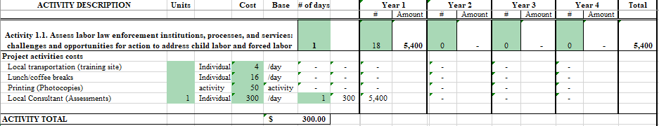

1.2. Strengthen Intersectoral Coordination by Re-Invigorating Referral Mechanisms and Strengthening Consejos and Juntas: A local consultant to develop guidance is included in the first two years at a daily rate of $300 for a total of 12 days each year. Printing the guides for each Canton is estimated at $200 for a total of $1,200 in Year 1. This activity is estimated at $4,800 in Year 1, $3,744 in Year 2, $0 in Year 3-4 for a grand total of $8,544.

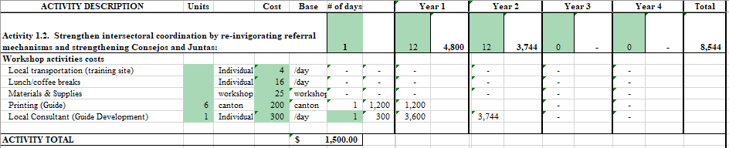

1.3 Develop Government Capacity Building Strategy Applying Assessment Results: N/A, costs leveraged w/other activities.

1.4 Develop, Deliver, and Institutionalize Capacity Building for Government Officials: POA is estimating the participation of 15 individuals for this activity of 6 workshops per year in Years 2-3 and 3 in Year 4. Printing for each workshop is estimated at $50 each. This activity is estimated at $0 in Year 1, $2,184 in Year 2, $2,271 in Year 3, and $1,181 in Year 4 for a grand total of $5,636.

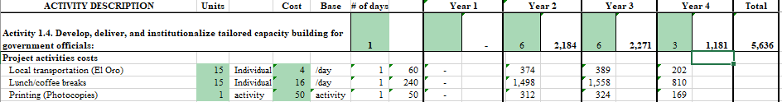

1.5 Strengthen Digital Child Labor Tracking and Public Reporting/Accountability: $75,000 has been estimated for software development in Year 1, $0 in Years 2-4 for a grand total of $75,000.

1.6 Partner with GADs to Integrate Enforcement Processes and Capacity Building into Local Community Development Plans and Budgets: POA is estimating the participation of 15 individuals for this activity of 18 meetings annually in Years 2-3 and 12 in Year 4. Printing for each workshop is estimated at $15 each. This activity is estimated at $0 in Year 1, $5,897 in Year 2, $6,133 in Year 3, and $4,252 in Year 4 for a grand total of $16,281.

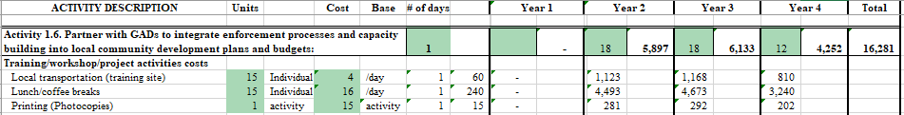

1.7 Disseminate Successes: POA is estimating the participation of 15 individuals for this activity of 6 meetings annually in Years 3 and 4 meetings in Year 4. Printing for each workshop is estimated at $500 each. This activity is estimated at $0 in Years 1- 2, $5,192 in Year 3, and $3,600 in Year 4 for a grand total of $8,791.

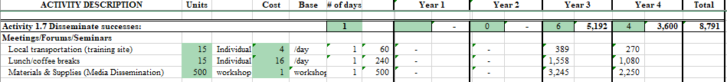

The total budgeted for Outcome 1 is $85,200 in Year 1, $11,825 in Year 2, $13,596 in Year 3, and $9,033 in Year 4, for a grand total of $119,653.

Outcome 2: Increased Worker Knowledge about Child Labor, Forced Labor, Occupational Safety and Health and Other Labor Rights in the Agricultural Sector

2.1 Assess Rural Workers’ Information Needs, Work Experiences, and Trusted Organizations: A local consultant to carry out surveys, KIIs, etc. for all 6 Cantons is included in the first year at a daily rate of $300 for 15 days. This activity is estimated at $4,500 in Year 1, $0 in Years 2-4, for a grand total of $4,500.

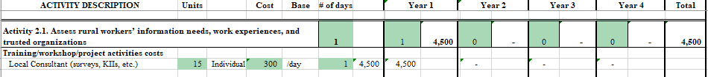

2.2 Build Capacity Of Worker Organizations, Producer Associations, And Other Actors To Reach Workers To Understand Their Rights: POA is estimating the participation of 20 individuals for this activity of 3 Training of Trainers annually in Years 2 and 3. Printing for each workshop is estimated at $50 each. Materials and supplies are estimated at $1,000 each to cover costs and fees for radio call-in shows, community fairs, posters, radio spots, etc. This activity is estimated at $0 in Year 1, $7,644 in Year 2, $7,950 in Year 3, and $0 in Year 4 for a grand total of $15,594.

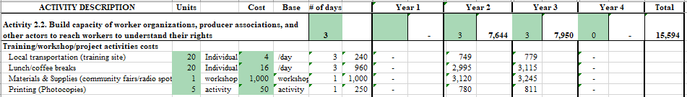

2.3 Institutionalize Worker and Community Training And Awareness-Raising: POA is estimating the participation of 20 individuals for this two-day activity of 8 producer association workshops in Year 4. Printing for each workshop is estimated at $50 each. This activity is estimated at $0 in Year 1- 3, and $7,649 in Year 4 for a grand total of $7,649

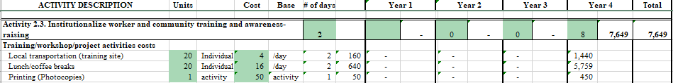

2.4 Establish and Convene Neutral Spaces for Bipartite and Tripartite Social Dialogue: POA is estimating the participation of 20 individuals for this activity of 4 meetings in Year 2, 12 in Year 3, and 4 meetings in Year 4. Printing for each workshop is estimated at $15 each. This activity is estimated at $0 in Year 1, $1,726 in Year 2, $5,386 in Year 3, and $1,867 in Year 4 for a grand total of $8,980.

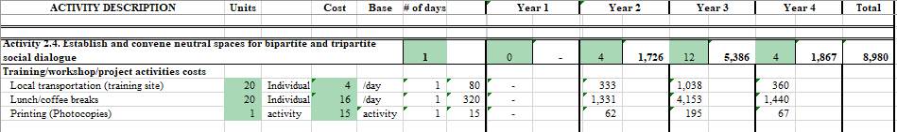

2.5 Train Small, Medium, and Large Employers to Engage Workers, Understand Workers’ Rights, and Monitor Rights Compliance in their Supply Chains: POA is estimating the participation of 20 individuals for this 2-day training of trainers workshop of 12 in both Years 2 and Years 3. Printing for each workshop is estimated at $50 each. Included is a local consultant at a daily rate of $300 to carry out the workshops. This activity is estimated at $0 in Year 1, $14,352 in Year 2, $14,926 in Year 3, and $0 in Year 4 for a grand total of $29,278.

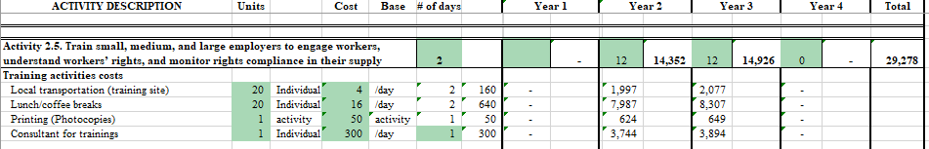

2.6 Partner With Gads To Integrate The Above Training, Awareness-Raising, And Social Dialogue Activities Into Community Development Plans : POA is estimating the participation of 9 individuals for this 2-day activity of 2 trainings annually in Years 3-4. Printing for each workshop is estimated at $50 each. This activity is estimated at $0 in Year 1- 2, $887 in Year 3, and $922 in Year 4 for a grand total of $1,809.

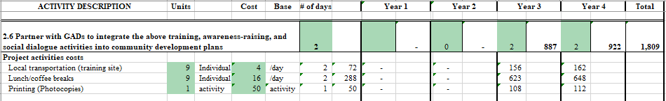

2.7 Generate New Opportunities For Learning Among Civil Society, Workers, Government, Private Sector, and Others: POA is estimating the participation of 18 individuals for this activity of 8 meetings annually in Years 3-4. Printing for each workshop is estimated at $50 each. This activity is estimated at $0 in Year 1- 2, $3,548 in Year 3, and $3,690 in Year 4 for a grand total of $7,237.

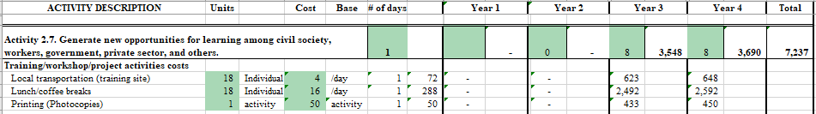

2.8. Assess Changes in Rural Workers’, Business, Community-Based Organizations, and Government Officials’ Knowledge, Skills, and Practices: Included is a local consultant at a daily rate of $300/day for 6 days each in Years 2-4 to develop data collection tools. Printing for each exercise is estimated at $50/each for an estimate for this activity of $0 in Year 1, $2,184 in Year 2, $2,271 in Year 3, and $2,362 in Year 4 for a grand total of $6,818.

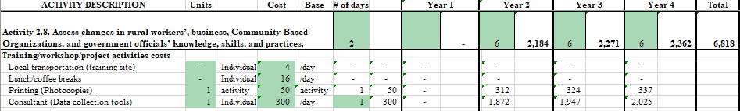

The total budgeted for Outcome 2 is $4,500 in Year 1, $25,906 in Year 2, $34,968 in Year 3, and $16,491 in Year 4, for a grand total of $81,865.

Outcome 3: Increased Worker Access to Remediation of Labor Law Violations Within the Agricultural Sector

3.1 Undertake Remediation Constraints and Opportunities Analysis: N/A, costs leveraged w/other activities.

3.2 Validate Analysis And Select Pilot Remediation Mechanism Designs: POA is estimating the participation of 20 individuals for this activity of 6 meetings in Year 2. Printing for each meeting is estimated at $50 each. This activity is estimated at $0 in Year 1, $2,808 in Year 2, $0 in Year 3-4, for a grand total of $2,808.

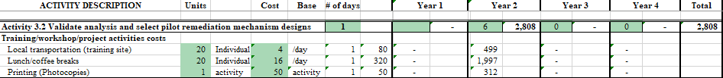

3.3 Engage Partners to Design, Plan, Implement, and Monitor Pilot Remediation Solutions: POA is estimating a cost of $2,800/pilot for 2 pilots in Year 2 and 4 in Year 3. Included is a local consultant to implement the pilots at a daily rate of $300/day over 3 days for each pilot, and printing cost of $50/pilot. This activity is estimated at $0 in Year 1, $13,416 in Year 2, $27,905 in Year 3, and $0 in Year 4 for a grand total of $41,321.

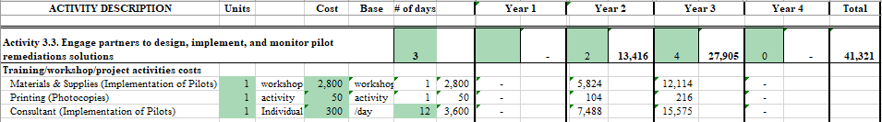

3.4 Finalize and Institutionalize Proven Grievance and Restitution Mechanisms: POA is estimating the participation of 20 individuals for this 3-day activity of 2 meetings in Year 2 and 4 in Year 3. Printing for each meeting is estimated at $50 each. A local consultant to roll out the grievance and restitution mechanisms is included at $300/day. This activity is estimated at $0 in Year 1, $3,848 in Year 2, $8,004 in Year 3, and $0 in Year 4 for a grand total of $11,852.

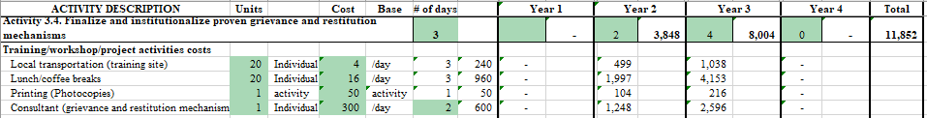

3.5. Develop And Integrate an Anonymous Reporting Platform: POA is estimating $500 in materials and supplies for a 3-day workshop, including $50/workshop, and a local consultant at a daily rate of $300/day to develop a reporting platform in all 6 cantons. Each $0 in Year 1, $10,608 in Year 2, $7,355 in Year 3, and $0 in Year 4 for a grand total of $17,963.

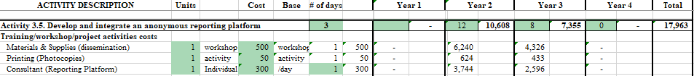

3.6. Engage Medium and Large Producers To Strengthen Grievance And Restitution Mechanisms In Their Workplaces And Supply Chains: POA is estimating the participation of 10 individuals for this 3-day activity of 4 trainings annually in Years 2-4. Printing for each training is estimated at $50 each. This activity is estimated at $0 in Year 1, $2,704 in Year 2, $2,812 in Year 3, and $0 in Year 4 for a grand total of $5,516.
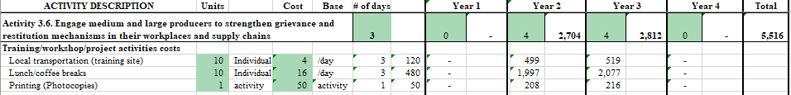

The total budgeted for Outcome 3 is $0 in Year 1, $33,384 in Year 2, $46,076 in Year 3, and $0 in Year 4, for a grand total of $79,460.

Monitoring, Evaluation, and Collections of Reliable Data

4.1 M&E Database Development and Creation of Digital Library for Resources

Consultant fees: POA is budgeting for a consultant to support the development of a customized M&E database, and the creation of a digital library for resources, to create sustainability. Based on prior consultant rates, POA estimates $315/day for 30 days in Year 1. The total cost is $9,450.

4.2 Monitoring Guidelines Development

Monitoring guidelines production and printing: POA is budgeting for the production and printing of monitoring guidelines at an estimated rate of $2,500/document for one (1) document developed in Year 1, for a total cost of $2,500.

Monitoring guidelines translation: POA is budgeting for the translation of the monitoring guidelines translation at a rate of $1,800/per document translation in Year 1, for a total cost of $1,800.

4.3 On-going M&E Training

M&E training workshop: POA is budgeting for the project M&E team to support and facilitate the development of M&E workshops in Quito, at an estimated rate of $300/workshop in Year 1 and Year 3. The total cost is $624.

Lodging and M&IE-on-going M&E training: POA is budgeting for the lodging, meals and incidentals for the project M&E team to support the M&E workshops in Quito at a rate of $115/day for 5 days in Year 1 and Year 3. The estimated total cost is $1,197.

Local transportation -on-going M&E training: POA is budgeting for local transportation (fuel and taxis) costs for the project M&E team to support with the M&E workshops in Quito at a rate of $30/day for 5 days in Year 1 and Year 3. The estimated total cost is $312.

4.4 CMEP Training

Development and Translation of CMEP: POA is budgeting $1,000 for the development and translation of the Comprehensive Monitoring and Evaluation Plans (CMEP) in Quito for one (1) workshop in Year 1. The estimated total cost is $1,000.

Workshop on CMEP: POA is budgeting $500/per workshop for the Comprehensive Monitoring and Evaluation Plans (CMEP) in Quito for one (1) workshop per year in Year 1 for an estimated total cost is $500.

Lodging and M&IE-on-going M&E training: POA is budgeting for the lodging, meals, and incidentals for the project M&E team to support with the CMEP training in Quito at a rate of $115/day for six (6) days in Year 1. The estimated total cost is $690.

Local transportation -on-going M&E training: POA is budgeting for the local transportation costs for the project M&E team to support with the CMEP training in Quito at a rate of $30/day for six (6) days in Year 1. The estimated total cost is $180.

4.5 Collection of Reliable Data and Processing of Monitoring Data

Lodging and M&IE-on-going M&E monitoring: POA is budgeting for the lodging, meals, and incidentals for the project M&E team to support with the CMEP training in Quito at a rate of $115/month for (1) staff in Year 1 and (2) staff/month in Years 2-4. The estimated total cost is $10,340.

Local transportation -on-going M&E monitoring: POA is budgeting for the local transportation costs for the project M&E team to support with the CMEP training in Quito at a rate of $30/month (1) staff in Year 1 and (2) staff per year from Years 2 through Year 4. The estimated total cost is $2,697.

Data Collection Materials and Printing: POA is budgeting for the production and printing of monitoring guidelines at an estimated rate of $500/document for one (1) document developed annually, for a total cost of $2,123.

4.6 Needs Assessment

Consultant fees to draft written needs assessment: POA is budgeting for 90 days in Year 1, for a consultant to develop and write a Needs Assessment report. Based on prior consultants for Needs Assessments, POA estimates $350/day. The total cost is $31,500.

Meeting expenses for needs assessment in Quito: POA is budgeting for venue and refreshments costs for a meeting to discuss and collect data for the need’s assessment. POA estimates $900/meeting for one (1) meeting in Year 1. The total estimated cost is $900.

4.7 External Evaluation

Interim Performance Evaluation: POA is budgeting for $60,000 in Year 2 for a contracted interim performance evaluation. This will cover evaluation costs, such as the translation of the evaluation report, ground transportation, interpretation, and stakeholder meetings.

Final Performance Evaluation: POA is budgeting $60,000 in Year 4 for a contracted final evaluation. This will cover evaluation costs, such as the translation of the evaluation report, ground transportation, interpretation, and stakeholder meetings.

The total budgeted for M&E is $51,785 in Year 1, $64,139 in Year 2, $5,413 in Year 3, and $64,447 in Year 4 for a grand total of $185,815 representing a little over 5% of the project’s direct total costs budget.

- Indirect Costs
Indirect Costs have been applied in accordance with POA’s cost structure as indicated in our NICRA. This document can be found as an attachment to the cost proposal. POA expects to use a 28.28% rate during all four years of project implementation. A summary of these charges are as follows:

Year 1 | Year 2 | Year 3 | Year 4 | Total
$216,806 | $290,012 | $292,897 | $245,243 | $1,044,958

Total project costs:
Year 1: $983,445
Year 2: $1,315,513
Year 3: $1,328,602
Year 4: $1,112,440

Project Grand Total: $4,740,000



Project to Improve Adherence to International Labor Standards in the Agricultural Sector in Ecuador
FOA-ILAB-23-28
INDES
Sub-Award Budget Narrative

INTRODUCTION

INDES is pleased to present the USDOL-funded Project to Improve Adherence to International Labor Standards in the Agricultural Sector in Ecuador with a total cost of $640,290.

In an effort to maintain efficiency, INDES has budgeted the direct costs for this program under the same assumptions as listed in POA´s budget.

PERSONNEL

Project Coordinator (40% LOE) – TBD: INDES is proposing a LOE of 100% and an annual salary of $37,500 ($3,125/month) based on INDES expertise and salary history with similar positions. The Project Coordinator will carry out the implementation of activities under INDES’ scope for this project. The total estimated cost over the life of the award is $52,220.

Technical Officers x 2 (100% LOE) – TBD: INDES is proposing 2 Technical Officers at 100% level of effort with an annual salary of $24,996 ($2,083/month) based on INDES expertise and salary history with similar positions. The Technical Officers will employ their specific areas producers with advising services regarding management, finance, accounting, and compliance to support the achievement of the projects’ programmatic outcomes. The total estimated cost is $105,783

M&E Officer (100%) - TBD: INDES is proposing an M&E Officer at 100% level of effort with an annual salary of $24,996 ($2,083/month) based on INDES expertise and salary history with similar positions. S/he will coordinate closely with POA´s M&E Officer to apply the M&E tools and activities set by POA. The total estimated cost is $87,033.

F&A Officer (100%): INDES is proposing a LOE of 100% and an annual salary of $20,244 ($1,687/month) for this position on salary history of similar positions in Ecuador. The F&A Officer will manage the day-to-day financial requirements under INDES sub-award report & coordinate the transparent and efficient management of the project’s financial and administrative systems, in accordance with all relevant USG, USDOL and local policies and regulations, including the implementation of controls to ensure transparency, and effective utilization of resources. S/he will coordinate the budget and daily disbursements, daily office operations, and financial reporting for INDES. The total estimated cost is $70,476.

The total budget for Personnel is $82,683 in Year 1, $89,506 in Year 2, $93,982 in Year 3, and $49,340 in Year 4, for a grand total of $315,511.

FRINGE BENEFITS

Fringe Benefits – Ecuador Staff: In accordance with local labor laws, we have budgeted a 43.33% rate on the salaries of all individuals performing duties under this contract in Ecuador. This rate includes:

12.15% - Social Security contributions (INSS)
8.33% - 13th month pay
8.33% - 14th month pay
4.11 % - Vacation premium
8.33% - Severance 1 month for each year of service
2.08% - Severance bonus (25% of the monthly salary)

Fringe benefits for Ecuador staff total $136,711.

The total budget for Fringe Benefits is $35,827 in Year 1, $38,783 in Year 2, $40,722 in Year 3, and $21,379 in Year 4, for a grand total of $136,711.

TRAVEL
Domestic travel applies to travel by INDES’ locally based staff in Quito traveling to the regions of Cotopaxi to carry out programmatic activities in these regions.

INDES budgeted $18 per round-trip to Cotopaxi for ground transportation based on average local costs in Ecuador.

Average Cost of Domestic Trips
# of DAYS | transport | lodging | M&IE | TOTAL
Cotopaxi | $9 | $25 | $47 | $81

The total budgeted for Travel is $120 in Year 1, $11,247 in Year 2, $13,373 in Year 3, and $4,155 in Year 4, for a grand total of $28,895.

EQUIPMENT
N/A

SUPPLIES
INDES has budgeted an estimated monthly cost of $60 for office use of general office supplies for INDES project staff to support this project for a total of $2,473 over the life of the project.

CONTRACTUAL
N/A

OTHER DIRECT COSTS

INDES Project Office
INDES Office space is budgeted at an allocation of $300/month (including all utilities, Wi-Fi, coffee, etc.) for project staff over the project's life for $12,363.

Program Activities
Associated with the program activities are related cost elements for participants’ travel ($4/day), lunch and coffee breaks ($16/day), consultant daily rates ($300/day) materials and supplies ($25-$1,000/workshop), and printing ($15-50/activity). The unit costs are based upon an average unit cost incurred in the proposed training sites (Cotopaxi/El Oro/Quito) in Ecuador.

The activities sections of the budget link directly to the activities worksheet “Activities Detail.” The activity costs in the detailed budget are presented as high-level summary, and the activities sheet is included to provide a detailed breakdown for each proposed activity.

Listed below are the total activities and amounts each year supporting program and training events for Direct Program Activities, Trainings, Meetings, and/or Workshop Costs to carry out this project's objectives. Each year includes a 4% escalation rate for inflation as previously noted in the assumption section above.

Outcome 1: Increased capacity of government officials to enforce labor laws specifically related to child labor, forced labor, occupational safety and health and other labor rights in the agricultural sector

1.4 Develop, Deliver, And Institutionalize Tailored Capacity Building for Government Officials: INDES is estimating the participation of 20 individuals for this activity of 6 workshops per year in Years 2-3 and 3 in Year 4. Printing for each workshop is estimated at $50 each. This activity is estimated at $0 in Year 1, $2,808 in Year 2, $2,920 in Year 3, and $1,519 in Year 4 for a grand total of $7,247.
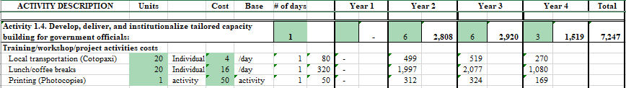

1.6 Partner with GADs to Integrate Enforcement Processes and Capacity Building into Local Community Development Plans and Budgets: INDES is estimating the participation of 15 individuals for this activity of 9 meetings annually in Years 2-3 and 6 in Year 4. Printing for each workshop is estimated at $15 each. This activity is estimated $0 in Year 1, $2,948 in Year 2, $3,066 in Year 3, and $2,126 in Year 4 for a grand total of $8,141.

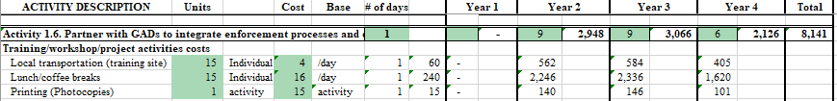

1.7 Disseminate successes: INDES is estimating the participation of 15 individuals for this activity in Year 4. This activity is estimated $0 in Year 1-3, and $337 in Year 4 for a grand total of $337.

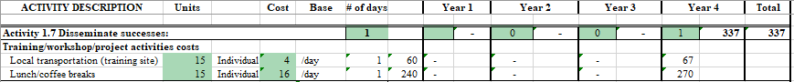

The total budgeted for Outcome 1 is $0 in Year 1, $5,756 in Year 2, $5,987 in Year 3, and $3,982 in Year 4, for a grand total of $15,725.

Outcome 2: Increased Worker Knowledge about child labor, forced labor, occupational safety and health, and Other Labor Rights in the Agricultural Sector

2.2 Build Capacity Of Worker Organizations, Producer Associations, And Other Actors To Reach Workers To Understand Their Rights: INDES is estimating the participation of 20 individuals for this activity of 3 Training of Trainers annually in Years 2 and 3. Printing for each workshop is estimated at $50 each. Materials and supplies are estimated at $1,500 each to cover costs and fees for radio call-in shows, community fairs, posters, radio spots, etc. This activity is estimated at $0 in Year 1, $9,204 in Year 2, $9,572 in Year 3, and $0 in Year 4 for a grand total of $18,776.

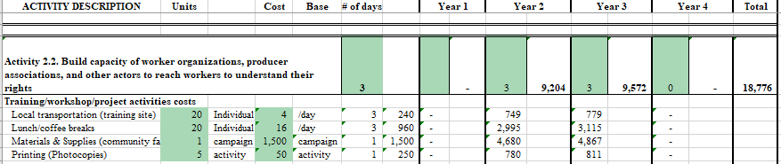

2.3 Institutionalize Worker And Community Training And Awareness-Raising: INDES is estimating the participation of 20 individuals for this two-day activity of 4 producer association workshops in Year 4. Printing for each workshop is estimated at $50 each. This activity is estimated at$0 in Year 1- 3, and $3,825 in Year 4 for a grand total of $3,825

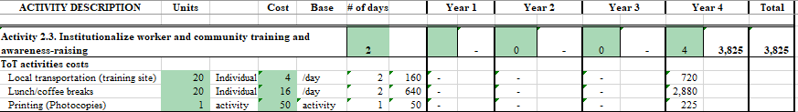

2.4 Establish and Convene Neutral Spaces for Bipartite and Tripartite Social Dialogue: IDNES is estimating the participation of 20 individuals for this activity of 4 meetings in Year 2, 12 in Year 3, and 4 meetings in Year 4. Printing for each workshop is estimated at $15 each. This activity is estimated at $0 in Year 1, $1,726 in Year 2, $5,386 in Year 3, and $1,867 in Year 4 for a grand total of $8,980.

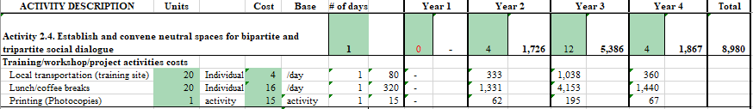

2.5 Train Small, Medium, And Large Employers to Engage Workers, Understand Workers’ Rights, And Monitor Rights Compliance in Their Supply Chains: INDES is estimating the participation of 20 individuals for this 2-day training of trainers workshop of 6 in both Years 2 and Years 3. Printing for each workshop is estimated at $50 each. This activity is estimated at $0 in Year 1, $5,304 in Year 2, $5,516 in Year 3, and $0 in Year 4 for a grand total of $10,820.

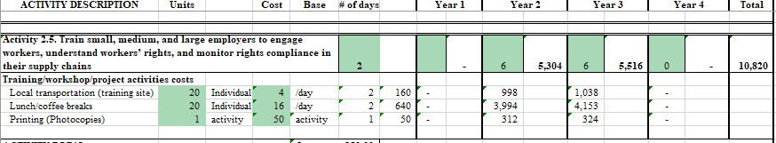

2.7 Generate New Opportunities for Learning Among Civil Society, Workers, Government, Private Sector, And Others: POA is estimating the participation of 20 individuals for this activity of 2 meetings annually in Years 3-4. Printing for each workshop is estimated at $50 each. This activity is estimated at $0 in Year 1- 2, $973 in Year 3, and $1,012 in Year 4 for a grand total of $1,986.

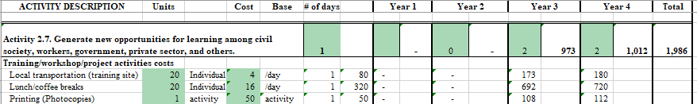

2.8 Assess Changes In Rural Workers’, Business, Community-Based Organizations, And Government Officials’ Knowledge, Skills, and Practices: : INDES is estimating costs for 20 individuals for 4 meetings annually in Years 3-4. and printing for each exercise is estimated at $50/each for an estimate for this activity of $0 in Year 1- 2, $1,947 in Year 3, and $2,025 in Year 4 for a grand total of $3,972.

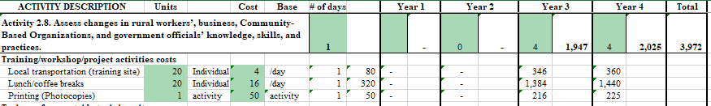

The total budgeted for Outcome 2 is $0 in Year 1, $16,234 in Year 2, $23,395 in Year 3, and $8,729 in Year 4, for a grand total of $48,358.

Outcome 3: Increased Worker Access to Remediation of Labor Law Violations Within the Agricultural Sector

3.1 Undertake Remediation Constraints and Opportunities Analysis: Costs for this activity are estimated at printing for each Canton at $50. $0 in Year 1, $302 in Year 2, $0 in Year 3-4, for a grand total of $302.

3.2 Validate Analysis and Select Pilot Remediation Mechanism Designs: POA is estimating the participation of 20 individuals for this activity of 6 meetings in Year 2. Printing for each meeting is estimated at $50 each. This activity is estimated at $0 in Year 1, $2,808 in Year 2, $0 in Year 3-4, for a grand total of $2,808.

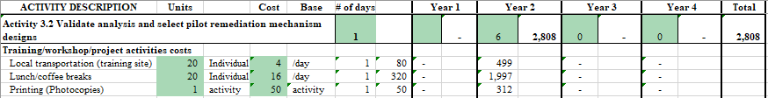

3.3 Engage Partners To Design, Plan, Implement, And Monitor Pilot Remediation Solutions: INDES is estimating printing cost of $50/pilot for 2 in Year 2 and 4 in Year 3. This activity is estimated at $0 in Year 1, $104 in Year 2, $216 in Year 3, and $0 in Year 4 for a grand total of $320.

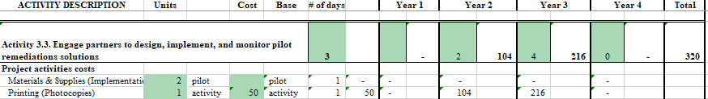

3.4 Finalize and Institutionalize Proven Grievance and Restitution Mechanisms: INDES is estimating the participation of 20 individuals for this 3-day activity of 2 meetings in Year 2 and 4 in Year 3. Printing for each meeting is estimated at $50 each. This activity is estimated at $0 in Year 1, $2,600 in Year 2, $5,408 in Year 3, and $0 in Year 4 for a grand total of $8,008.

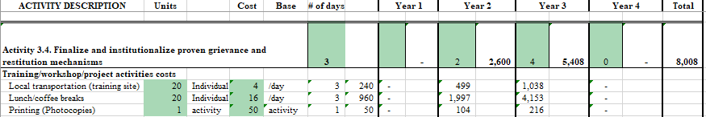

3.6. Engage Medium And Large Producers To Strengthen Grievance And Restitution Mechanisms In Their Workplaces And Supply Chains: INDES is estimating the participation of 20 individuals for this 3-day activity of 4 trainings annually in Years 2-4. Printing for each training is estimated at $50 each. This activity is estimated at $0 in Year 1, $5,200 in Year 2, $5,408 in Year 3, and $0 in Year 4 for a grand total of $10,608.
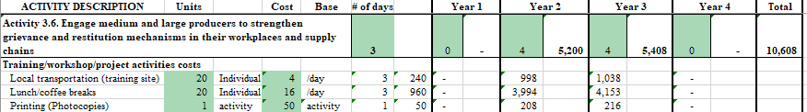

The total budgeted for Outcome 3 is $0 in Year 1, $11,014 in Year 2, $11,032 in Year 3, and $0 in Year 4, for a grand total of $22,046.

INDIRECT COSTS
INDES does not have a NICRA. Therefore, the 10% de minimis rate has been applied to all direct costs for a total of $58,208.

Year 1 | Year 2 | Year 3 | Year 4 | Total
$12,187 | $17,703 | $19,316 | $9,002 | $58,208

Total project costs:
Year 1: $134,056
Year 2: $194,737
Year 3: $212,479
Year 4: $99,017

Project Grand Total: $640,290

